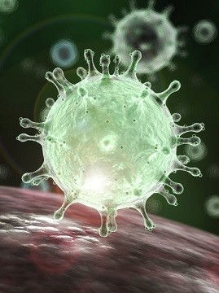

SARS COVID 19

Why should we be interested?

Richard Noake | Investigation | Spring 2020

# Why bother?

Why should you be interested?

Well within your lifetime there is likely to be an accelerating pace of attacks by zoonotic viruses. The question is why the accelerating pace? Where are they coming from? Is it true that there is an increase in the incidence of these events? Investigation of the literature will illuminate many ‘nearly’ pandemics where cross species infection has led to transmission to human hosts. There is also the historic perspective, looking back how have past pandemics (1918 Spanish Flu etc.) altered society or behaviors etc.

Topics for further investigation.

Why should it be so? Is it indeed true?

* Climate change. This is a whole other subject and links in to just about every other item here.
* Habitat destruction causing wildlife to come into closer contact with human populations. Also forcing different animal species to interact when they might not otherwise have done. Cross species boundaries overrun as in the case of COVID 19.
* Population pressure. The inexorable increase in the human population has multiple effects. Higher densities within cities, transport links and the densities within. Global interconnectedness.

## OK why did i bother?

Well it’s a topic I am interested in, bringing together mathematics, statistics, biology, ecology and behavior / psychology, both human and animal. I could also see that the topic crossed boundaries of subjects that both Ben and Alisha would at some point be taking exams on. And I would be willing to bet that examiners are thinking questions up right now based on our current predicament!

## Mind map

The COVID 19 mind map give a brief overview of the topic providing oversight of the linkages between the various subject areas. Note how we might categorize things as Biology or Psychology but in reality, these things are all related and cross discipline working is the way to approach the data.

The topic area of chemistry in relation to virus and infection is an area I have not covered by there must be mileage in this.

## Practical mathematics

There is a whole load of math’s and statistics work involved here. Even reading up the reports etc. requires some understanding of the math’s underpinning the presentations.

Real life is messy hence the fact that most of government and health policy is based on algorithms and computer models, not actual data. So, should you wish to further develop ICT skills simple computer models can be built and run in Python etc. and results presented.

## OK over to you…

So that’s my take on this. Mark my work, what did I miss? What did I get wrong? How would you have done this differently? And where would you take it now?